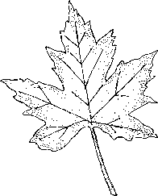
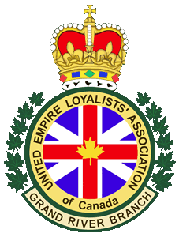

United Empire Loyalists
#6
The Evaporators

From the LP – ‘United Empire Loyalists’

Nard Wuar Records

Vocabulary

- civil war -
- revolution -

38

Do You Know It?

- What war is being discussed in the song?

- The American War of Independence, or the American Revolutionary War, was fought from 1775 to 1783, yet the year 1776 is given for the war. This is due to the fact that something was signed that year that signified that the United States was no longer under British control. What is the name of that document?

- The American Civil War was fought between the years of 1861 and 1865. Who was this war between and why was it being fought?

- Why would we say this should be considered a civil war rather than a revolution?

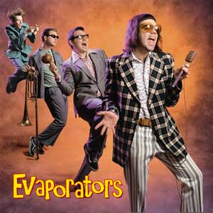

The Evaporators were formed in the early 90’s. The band is fronted by the highly eccentric and entertaining Nardwuar, the Human Serviette. Nardwuar has also made a name for himself as a guerrilla journalist who leaves his interviewees in awe and disbelief. His “victims” include: The White Stripes, Courtney Love, Snoop Dogg, and former Prime Minister, Jean Chrétien. The other band members include guitarist David Carswell, bassist John Collins, and drummer Scott Livingstone.

Artist Information

